End of Month Reports

Bankruptcy Report
Need to identify bankruptcy loans that have a future due date and have a bankruptcy loan stop and/or a bankruptcy mortgage status code. We must identify these loans and make a correct on MS in order to correctly report them on the HUD delinquency file.

The information needed is Loan #, Name, Due Date, Loan Stop Code, Mortgage Status Code

- These are the mortgage status codes found on the Default/Credit Reporting screen, Report tab, at bottom of page. Dropdown box.

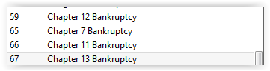
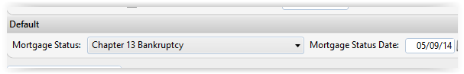

- These are the loan stop codes, located on the General, Loan Stops Screen, Loan Payment Stops tab.
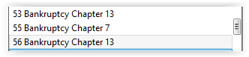
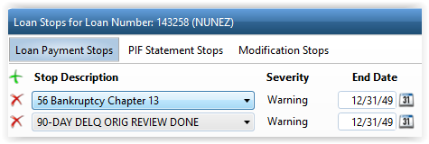

- In this example (ln # 143258), the loan has a 67 Chapter 13 mortgage status code, a 56 bankruptcy loan stop and a due date of 7/1/17 as of June 30, the last day of the month when we would pull this report.

MS code
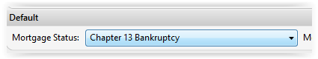
LS code
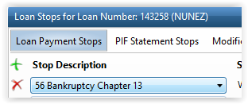

Due Date
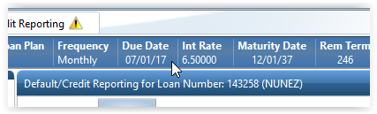

If the loan has either or both of these bankruptcy codes on the mortgage status and/or loan stop screens, and the due date for the loan is future month, they need to be identified. Ex: When we pull this report on June 30th, it would have either code and would have a due date of 7/1/17 or 8/1/17 or any other future date.

